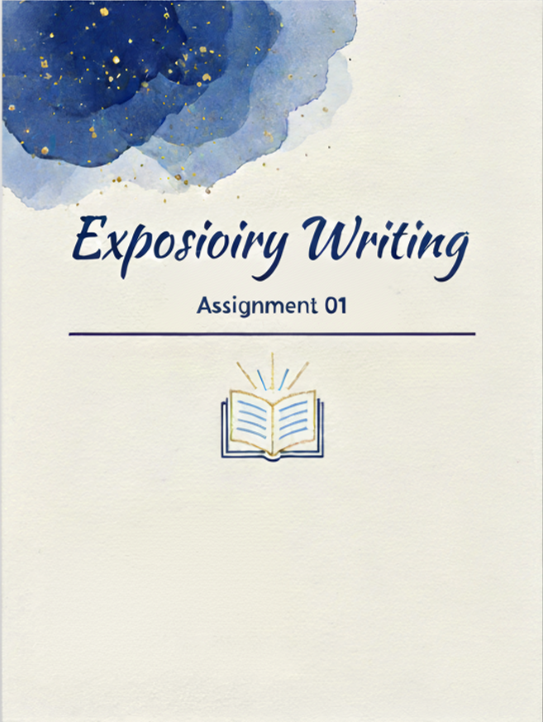

Name : Muhammad Shamoil
Section : BSSE-V-A
Date: 2nd November 2025
Submitted to : Sir Mohey ud Din Aurangzeb
Claims | Evidences
The problem of people believing fake news has become serious, mainly due to foreign influence and the political culture that accepts false claims if they fit one’s beliefs. [Line 2] | The author refers to events like the 2016 foreign interference and mentions that people often believe false claims that align with their ideology. [Line 2]
There are two main reasons people fall for misinformation: one is rationalization (motivated reasoning) and the other is cognitive laziness (not using critical thinking). [Line 3] | The author describes two schools of thought — some think reasoning is used to defend beliefs, others think people just don’t think deeply enough. [Line 3]
Both rationalization and cognitive laziness explain the problem, but knowing their balance can help make better policies. [L-4] | The author explains that both ideas capture part of the truth, and understanding their mix can help design good interventions. [Line 4]
The rationalization view claims that people use reasoning to justify political sides, and smarter people may rationalize even better. [Line 5] | The article says reasoning becomes “hijacked” by political loyalty, making intelligent people more capable of defending wrong ideas. [Line 5]
Some research supports rationalization, such as Kahan showing smarter people are more divided on climate issues and Nyhan & Reifler showing corrections can backfire. [Line 6–7] | The author cites Kahan’s and Nyhan & Reifler’s studies as examples where better reasoning or corrections didn’t reduce bias but sometimes increased it. [Line 6–7]
The authors believe rationalization is not the main reason; it’s more often that people don’t engage critical thinking at all. [Line 8] | They mention that the more natural reason is people not thinking critically enough when reading information. [Line 8]
Cognitive psychology research shows that people who think analytically are less likely to believe superstitions or conspiracies, meaning critical thought protects against fake news. [Line 9] | The article mentions that analytical thinkers are less superstitious and less likely to accept vague but impressive-sounding claims. [Line 9]
In their own research, people who scored higher on the reflection test were better at identifying real and fake news, no matter their political views. [Line 10–11] | They used the Cognitive Reflection Test (CRT) with real social media headlines and found that reflective thinkers judged truth more accurately regardless of politics. [Line 10–11]
This result was also repeated in a national survey and even applied to spotting exaggerated political reporting. [Line 11] | The author says they repeated the study on a larger sample and found the same pattern for detecting extreme partisan coverage. [Line 11]
Encouraging reasoning should be part of the solution, and contrary to popular belief, corrections usually improve understanding instead of making it worse. [Line 12] | They argue for promoting critical thinking and note newer studies showing corrections generally help people become more accurate. [Line 12]
Reasoning generally helps people reach truth, and cases where reasoning strengthens bias are rare exceptions. [Line 13] | The authors agree that Kahan’s findings exist but say they are exceptions; in most cases, reasoning supports accuracy. [Line 13]
Policies should focus on spreading true information and training people to think critically, since humans are not naturally unreasonable. [Line 14] | The conclusion calls for investing in accurate information and critical thinking education to help society resist fake news. [Line 14]

